A Difficult Summer…

At the start of 2020 Newcastle Cathedral became a building site! After January, our Monday organ recitals relocated to the Lewis-Willis instrument at Jesmond URC – not the cathedral’s only connection with that church, as it happens. Ian and Diana Whaley worship there, both their sons were cathedral choristers, and of course we still enjoy their company in Fitz Choir.

We used just the east end of the cathedral, as work began in the Nave. I was there at February Half-Term… but plans for the rest of that term, in churches and schools, would of course be dramatically changed. At Jesmond, an initiative of ‘social distancing’ for the recitals was tried using the modern, flexible seating; but ‘lock down’ soon prevailed.

Possibilities for public worship – let alone vacation choirs – don’t look good as I write in this next (May) Half-Term week. However, it has been good to see colleagues using this difficult time to think and come up with initiatives.

Among the first churches to ‘stream’ services and music online was Pannal, in North Yorks, where Kevin and Sarah Paynes co-ordinate the music – Kevin is no stranger to us, having conducted at several of our events. Back in 2012, their choir directed by Kevin made a very creditable CD of hymns and anthems (featuring the 1887 Willis organ at their other church, Beckwithshaw), and tracks from it have contributed to the ‘streams’ – with some ingeniously ‘mixed’ recordings of choir members in their homes, usually to Sarah’s accompaniment (from last-ditch recording in church, just a few hours before lock down!). The YouTube videos are worth seeing – go to ‘Pannal with Beckwithshaw’ (if you ‘subscribe’ it doesn’t cost anything!); they go back to Mothering Sunday, and the Easter Day one got more than 950 ‘views’.


There’s a video of Nigel the Donkey on Palm Sunday at Pannal…

A bit further north, the Taylor family in Ripon (Roger, Helen, and Lucinda) are well known to us too. Apart from singing, Lucinda is a Harp specialist – here she is, helping to celebrate a socially distanced local birthday! Several other live performances have followed.

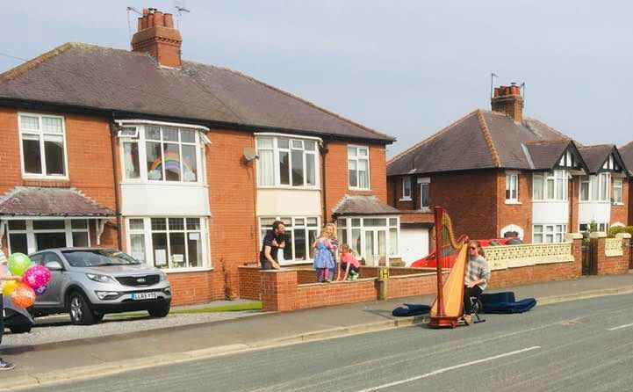
Forget the Ripon Hornblower – it’s the Ripon Harpie!

Continuing north; Fitz Choir hasn’t sung at St Oswald’s in Durham (not yet, anyway), but it’s where I learned to accompany services back in 1971 and I’m in touch with the DoM, David Harris. David has also used YouTube, making ‘Social Distance Sing’ videos – initially for his own choir, but I think many others would enjoy them. David deals with a selection of hymns, a psalm, and now Tallis’s “If Ye Love Me” (at modern pitch – sorry, Martin!).

Mentioning Martin, he and I have been accepted by Network Rail for ‘contingent’ duties on the Newcastle-Carlisle line. We await ‘call up’, and meanwhile Martin has made a video version of a thought-provoking talk which he was due to give in Stockholm: https://strivingsignaller.wixsite.com/bks-media/what-s-happening-to-my-voice

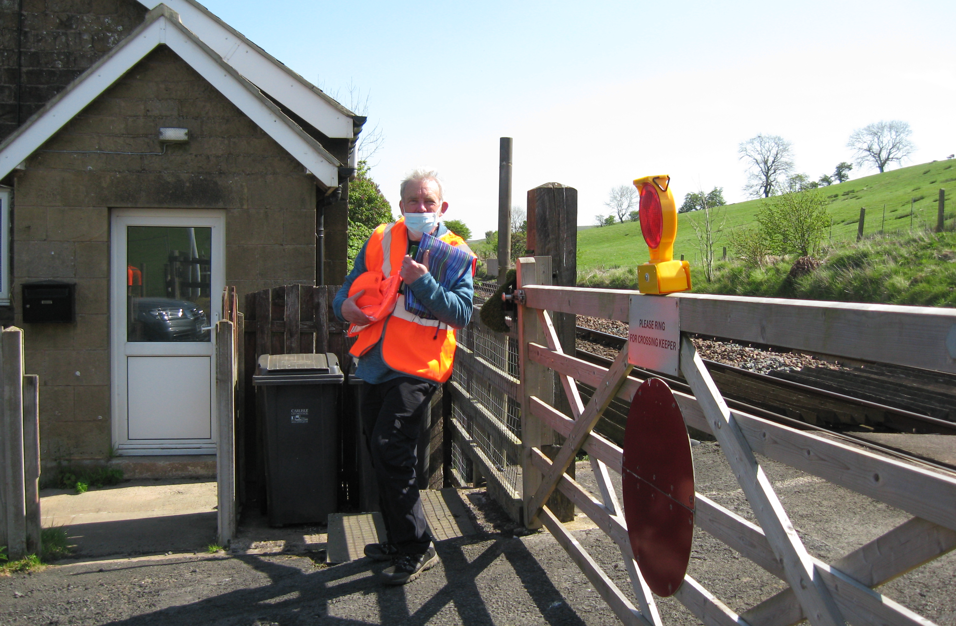
Lane Head Crossing, Cumbria, May 2020 – Martin in PPE and face mask! Does an anthem by Julius Harrison come to mind?

In Newcastle itself, our supporters Lesley Wright and Gilly Box give an encouraging account of their own church choir, and of communications within their church actually improving in some ways. Gilly’s four-year-old daughter contributed a little ‘bonus’ at Easter, which they’re happy to share: https://youtu.be/lusgzk6kWFo

Gill Blazey and Enid Mitchell, among other ‘locals’, mention ZOOM choir contacts which can offer good moral support – an important point, which I feel we shouldn’t neglect even though music-making opportunities as such may be limited.

Finally, with the reduced traffic noise and pollution I got an unexpected lesson in our garden on Block Signalling! Janet pointed out how bird song is actually clearer and more subtle at present, and we heard a blackbird sound an ‘alarm’ call, which another repeated back before flying to a high vantage point to look out for danger. I wonder whether mid-C19 railway engineers were more aware of Nature than we tend to be, and more prepared to learn useful insights from Nature?

I’ll keep everyone informed about any Choir possibilities, of course. Meanwhile, please stay safe!

Kieran
May 2020

